HS 100 - for Hard Anodizing of Aluminium
铝件硬质阳极氧化 HS100
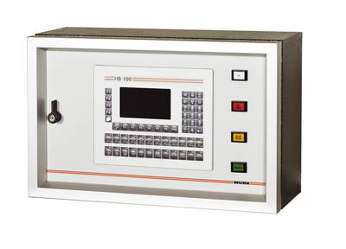
Application: 应用范围
The HS 100 Process Controller is applied for Hard Anodizing Processes. The remote control provides you with the flexibility needed for the different requirements given to successfully anodize various aluminum alloys. In addition to the standard DC mode you can also apply various pulse patterns to the load being anodized. The controller is installed directly at the tank and is mainly used in manual or partly automated anodising plants. The optional Pro Ano software provides process data logging and allows real-time verification from the main control room.
HS100工艺控制器适用于硬质阳极氧化工艺，并且为不同需求的各种铝合金的成功氧化提供了所需的灵活性。除了标准的直流电模式，还可以针对阳极氧化的荷载情况使用各种脉冲模式。控制器可直接安装在槽边，主要用于手动设备或半自动阳极氧化设备。可选的Pro Ano软件提供了生产过程的数据记录，并且允许从主控制室进行实时监控。

Product Description: 产品描述
Ramping, pulse operation, current control, and voltage control – all these features are standard in the Process Controller HS 100. By means of the programme buttons P 1 – P 24 you can activate one of the 24 available programmes. Each programme can consist of up to 10 steps. For each step you can use one of the following functions to create a complete programme sequence (ramp, pulse, hold, repeat). Thus you can define various different ramping cycles or pulse cycles within one programme. The desired current or voltage value can be individually defined for each step of the process. You can generate a single polarity pulse pattern by means of the pulse function. The minimum pulse time is 1 sec. The remaining process time is automatically calculated and displayed. Automatic dosing is possible and 72 programmes can be stored. Furthermore, a
scanner function links orders and process details together.
斜坡、脉冲操作、电流控制、电压控制，这些都只是工艺控制器HS100的标准功能。通过程序按钮P1-P24，能够激活24个不同程序中的任意一个。每个程序最多包含10个步骤，而且可以为每个步骤选择下面任一功能从而创建一个完整的程序（斜坡、脉冲、保持、重复）。因此在一个程序里就可以定义不同斜坡周期或脉冲周期，同时工艺的每个步骤都可单独设定所需电流或电压值。另外通过脉冲功能可以生成单向脉冲波形，最小脉冲时序是1秒。最后剩下的工艺程序是将则会自动计算生成并显示出来。控制器具有自动加料功能，最多存储72个程序。此外，自带的扫描功能能使得订单信息和生产过程信息一一对应。
Customer Benefits: 客户利益
The user knows how to utilize the benefits of the Process Controller HS 100! The fabric surface programme is very easy to handle and therefore productivity is increased and the user can save money. The HS 100 also creates process security and helps the user to obtain advantages of quality and efficiency.
用户知道该如何发挥AS100工艺控制器的优势，即通过控制电流密度提供生产率，达到节约成本。AS100工艺控制器实现安全生产，同时帮助用户获得了高质量和高效率的生产。

Technical Data: 技术参数
Dimensions (W/D/H) 尺寸: | 600 / 235 / 380 [mm]
Weight 重量: | 35 kg
Finish 颜色: | RAL 7035

Drawing: 图纸
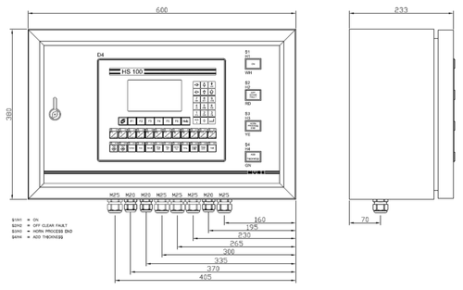
Interfaces: 通讯接口
Analog Adjustment (0-10 V_{DC}, 4-20mA)
Digital adjustment control commands or fieldbus, for example Profibus DP
Brochure:
Brochure_HS100.pdf (98 K)

